**CMP510 (AR and VR Technologies)**

**Assignment 1**



**Navrachana University**

Name: Sakshi Shah

ID: 22000275

Batch D

Subject: AR VR

**Objective:**

To create a basic virtual environment in Unity that includes a ground plane, a skybox, environmental objects, lighting, and simple VR interaction. The player should be able to grab and move the grabbable objects in the environment.

STEPS:

**Task 1: Set Up Your Unity Project & Configure the VR Environment**

* Go to Edit > Project Settings > XR Plugin Management.
* Select the platform and install OpenXR for cross-platform VR support.
* Go to Window > Package Manager> XR Interaction Toolkit> install it.
* Right-click in Hierarchy and choose XR > Device-based > XR Rig.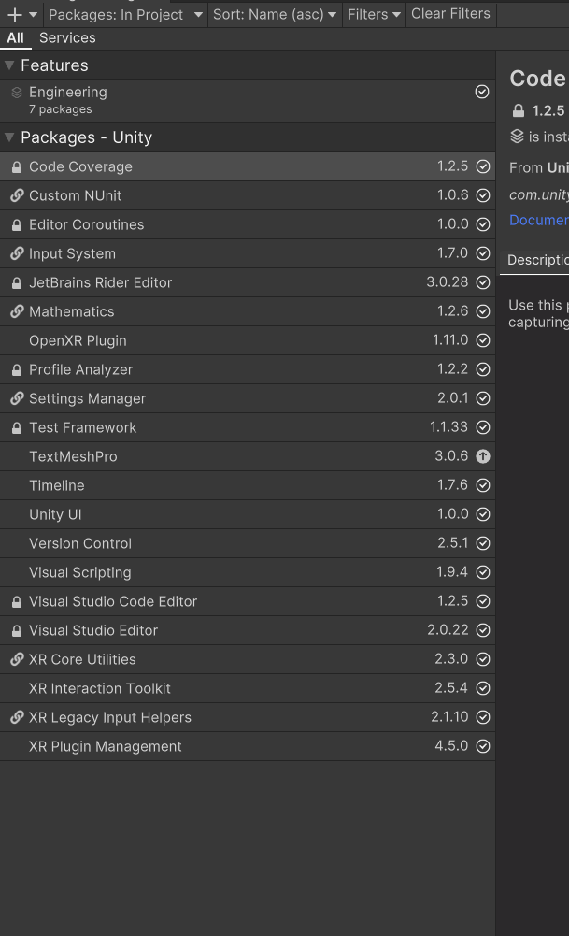

**Task 2: Create the Ground Plane**

* Right-click in the Hierarchy> 3D Object > Terrain.
* Click on the Terrain object> Inspector panel> Terrain Settings> width = 50 and length= 50.
* In inspector Paint Terrain tool> Set Height= 0
* Go to asset store> different grounds> download> import
* Select Terrain > Paint Texture and assign a ground texture through brush.

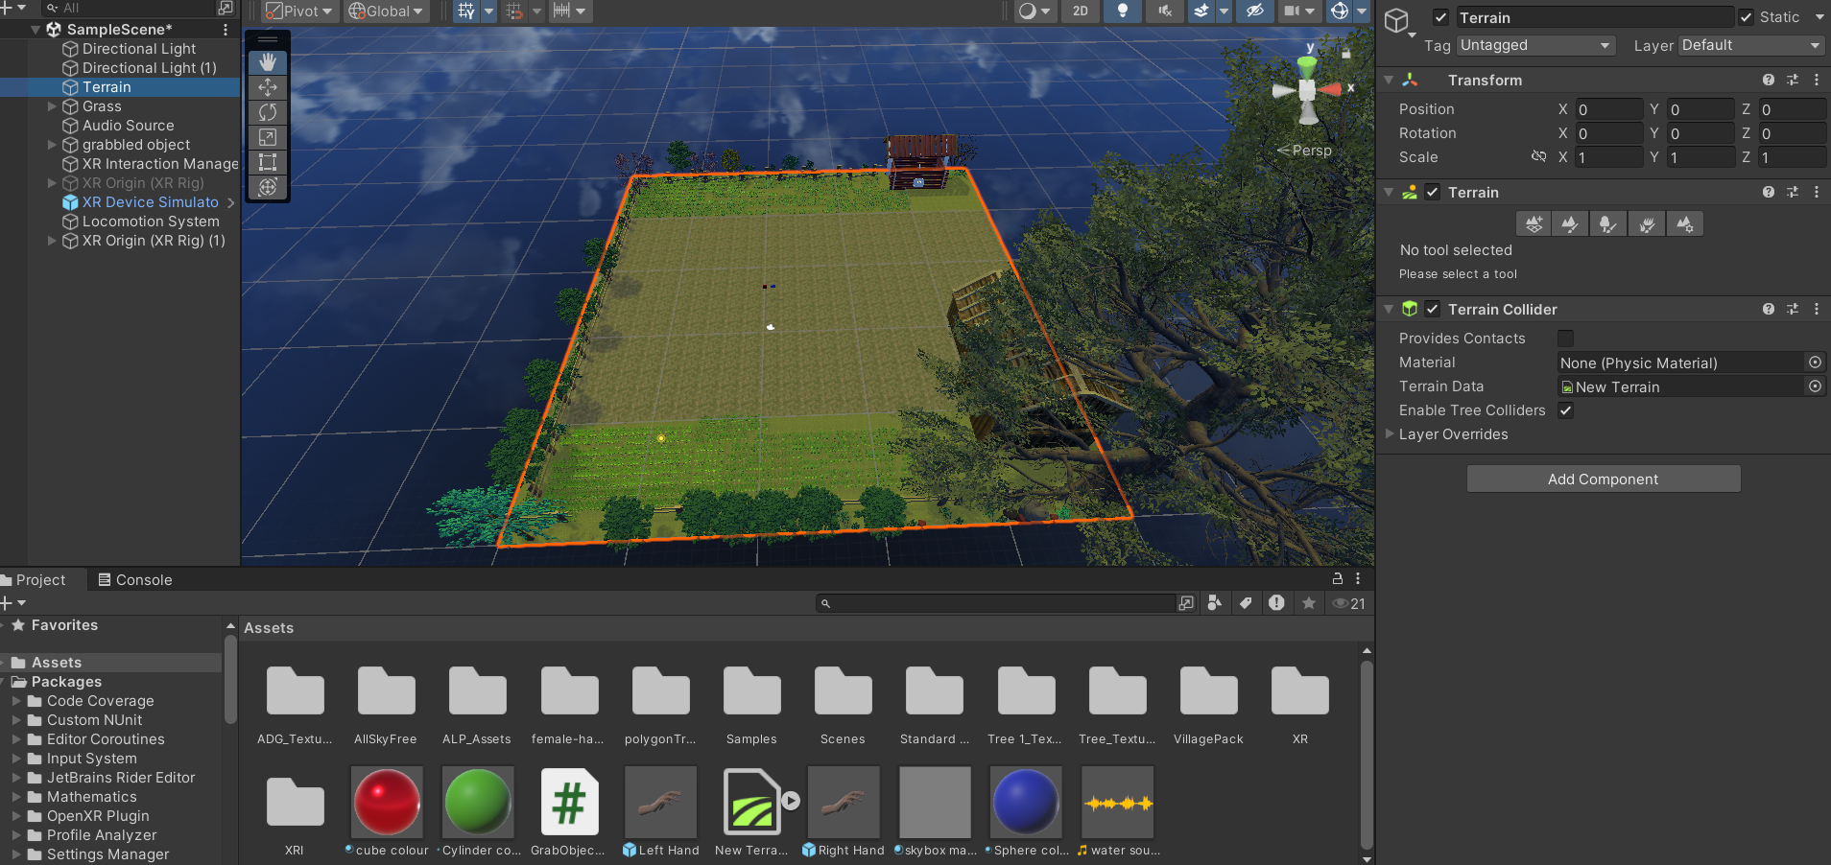

**Task 3: Add a Skybox**

* Go to asset store> sky > download> import
* Go to Window > Rendering > Lighting Settings.
* Enviroment > Skybox Material field> Select sky.
* Scene> Lighting setting as> adjust Sun Intensity.

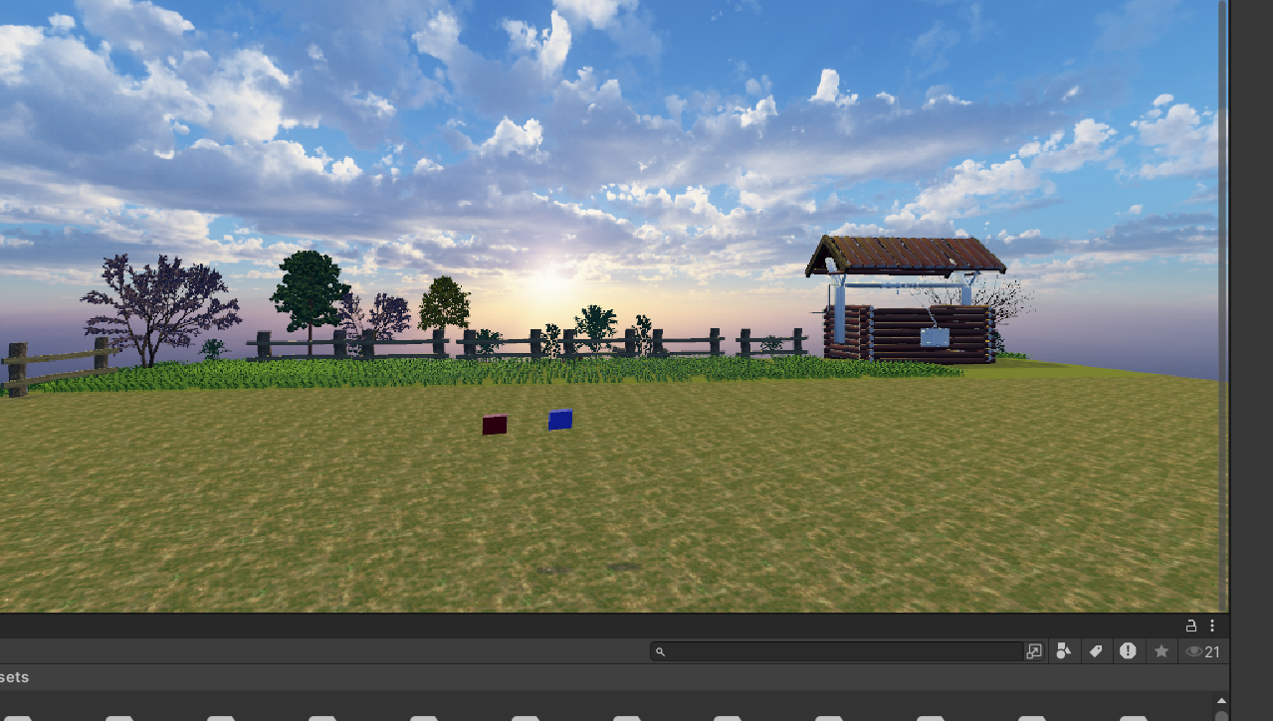

**Task 4: Add Environment Objects**

* Go to asset store> village and old house> download> import
* Place trees, house, well, gras, shrubs etc in the scene
* Right-click in the Hierarchy> 3D Object> cube
* Right-click in the Hierarchy> 3D Object> sphere
* Position them randomly on the terrain.
* Right-click in the Hierarchy> Create Empty> GrabbableObject> drag 3D objects in it.

Enviroment Objects 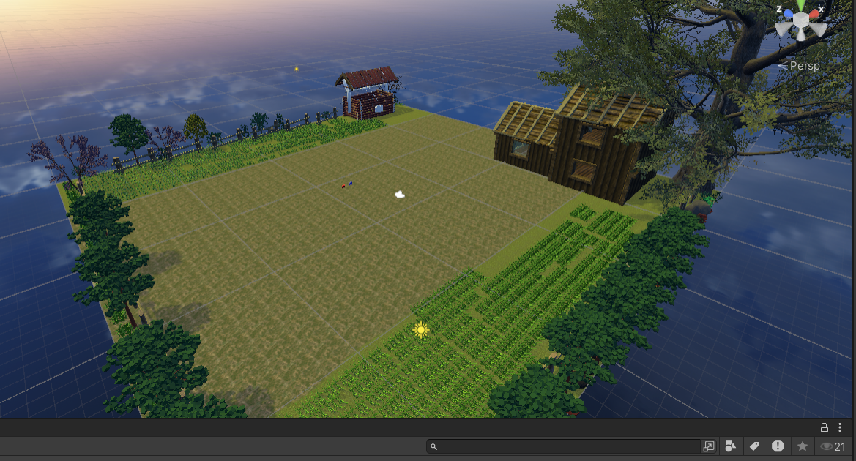

Red & Blue Cube Grabble Objects



**Task 6: Configure Lighting and Shadows**

* Go to GameObject > Light > Directional Light.
* Adjust its rotation to simulate sunlight.
* In the Inspector> Shadow> Soft Shadows. 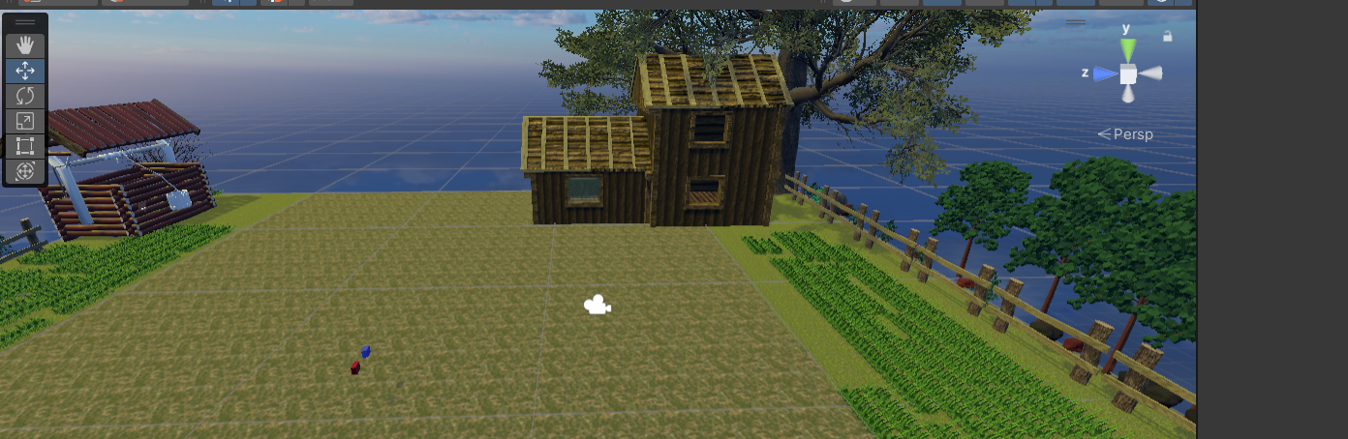

**Task 7: Add Audio**

* Download and save audio in folder.
* Right click in asset> import new asset> custome asset> select the audio.
* Right-click in the Hierarchy> select Audio > Audio Source> Rename it.
* Audio Source> Inspector> AudioClip field> drag audio from asset in it.
* Go to hierarchy place the audio source in the relevant location in scene.
* Test the Audio by playing the scene and moving closer to the audio source. 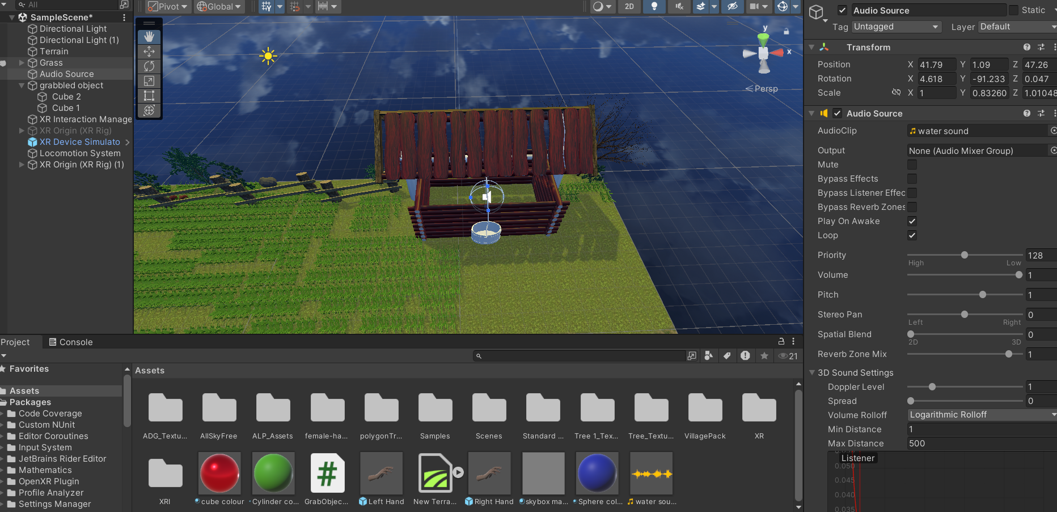

**Task 8: Implement Basic VR Interaction**

* Create a Grabbable Object
* Add Grabbable and Grabber Components
* Select any object you want to make grabbable.
* In the Inspector window, click Add Component.
* Search for and add the XR Grab Interactable component. This component will allow the object to be interacted with.
* A Rigidbody component is needed to allow physical interactions
* Go to Add Component and search for Rigidbody.
* Make sure to adjust the Rigidbody settings for smooth interaction.
* Select your hand controllers.
* Add the XR Direct Interactor or XR Ray Interactor component, depending on how you want to grab objects (direct touch or ray-based interaction).
* Ensure that the XR Grab Interactable script on the object and the XR Interactor script on the hand interact properly.
* Press play in Unity’s Game Mode and use your assigned keyboard buttons (e.g., LSHIFT for right hand, SPACEBAR for left hand) to test if your hands can grab the object.
* Press Play and test grabbing the objects in VR by moving your hands toward them. 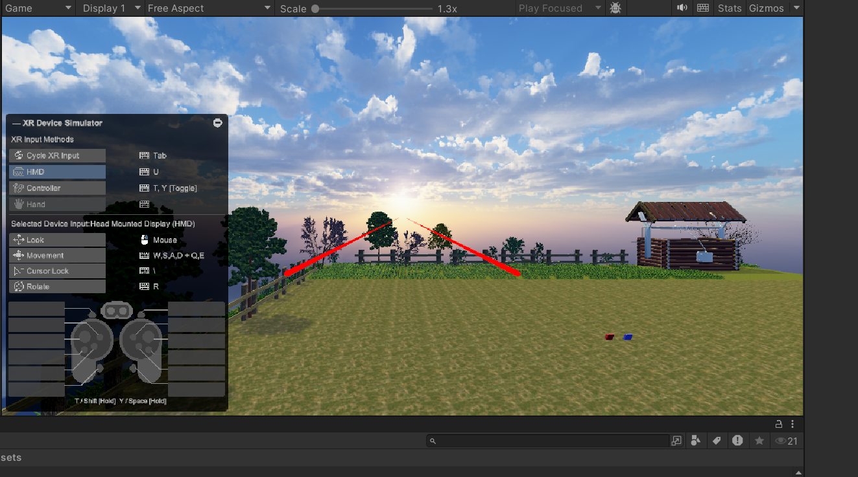

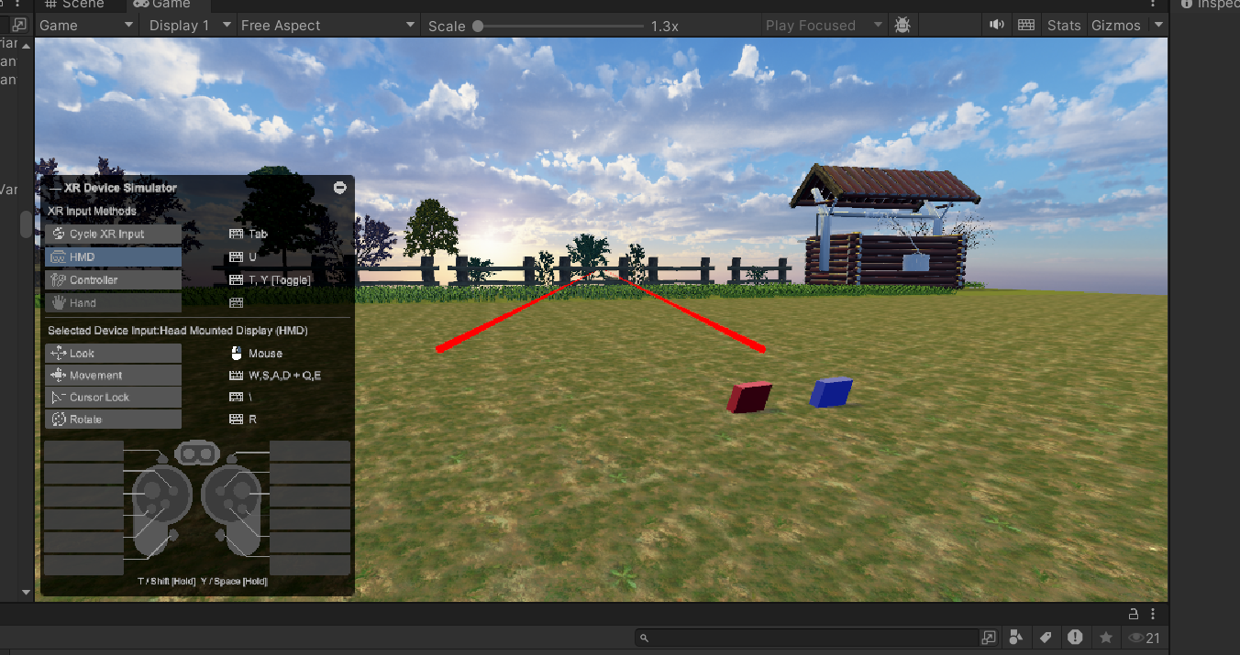

**Task 9: Write the VR Interaction Script**

* Ensure your gem objects have an XR Grab Interactable component from the XR Interaction Toolkit. This will allow them to be grabbed.

**Modify NewBehaviourScript to Work with VR Interactions**

using System.Collections;

using System.Collections.Generic;

using UnityEngine;

using UnityEngine.Events;

using UnityEngine.XR.Interaction.Toolkit;

public class ObjectGrabScript : MonoBehaviour

{

[SerializeField] private int numberOfObjects;

private int numberOfObjectsInSocket = 0;

public UnityEvent unlock;

public void AddObject()

{

numberObjectsInSocket += 1;

CheckForAllObjects();

}

private void CheckForAllObjects()

{

if (numberOfObjectsInSocket == numberOfObjects)

{

unlock.Invoke();

}

}

public void RemoveObject()

{

numberOfObjectsInSocket -= 1;

}

public void OnGrab(XRBaseInteractor interactor)

{

Debug.Log("Object grabbed by: " + interactor.name);

}

public void OnRelease(XRBaseInteractor interactor)

{

Debug.Log("Object released by: " + interactor.name);

}

}

Step: 3 Attach VR Interaction Components

* For each Gem, add the XR Grab Interactable component from XR Interaction Toolkit.
* Also, add a Collider (probably a Box or Mesh Collider) and a Rigidbody (set it to Kinematic) so that the object can be grabbed.
* You can create an XR Socket Interactor where the gems need to be placed.
* When a gem is placed in the socket, it will trigger the AddGem() function.
* Press Play and test the grab/release interaction with the VR controllers. 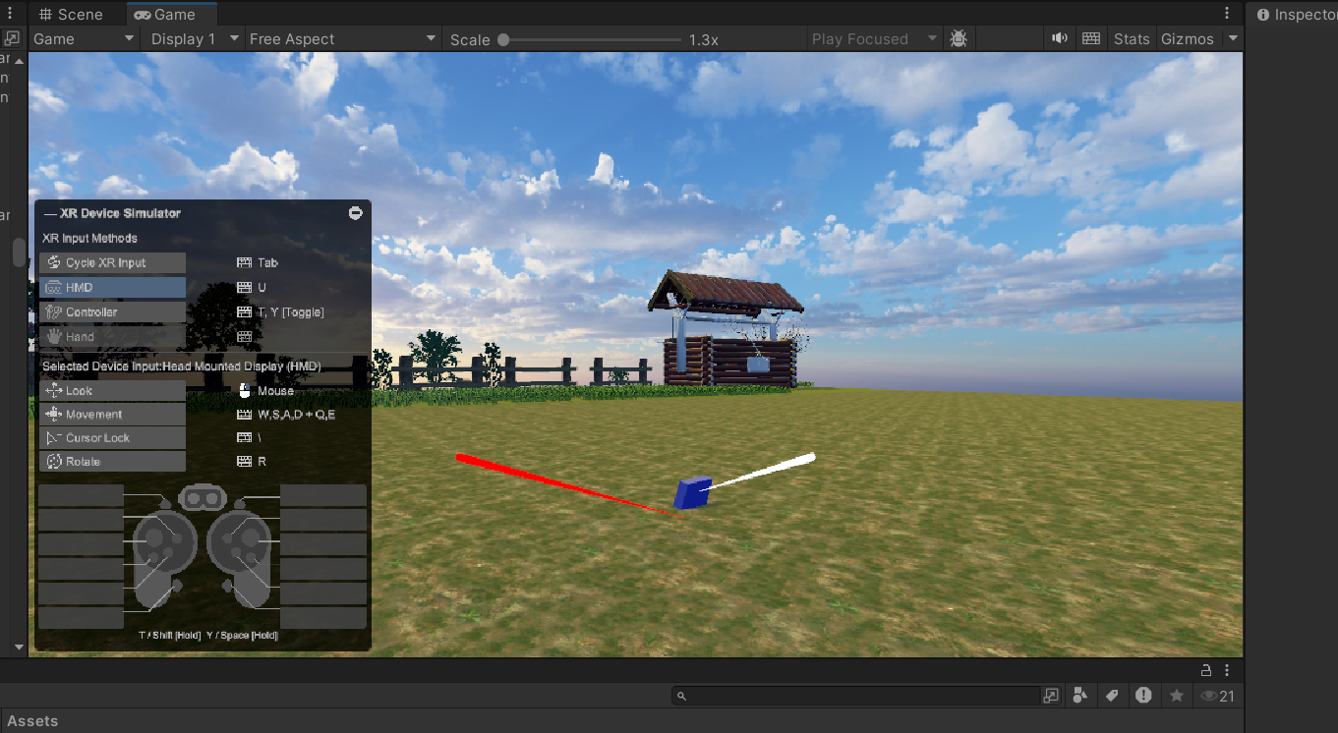

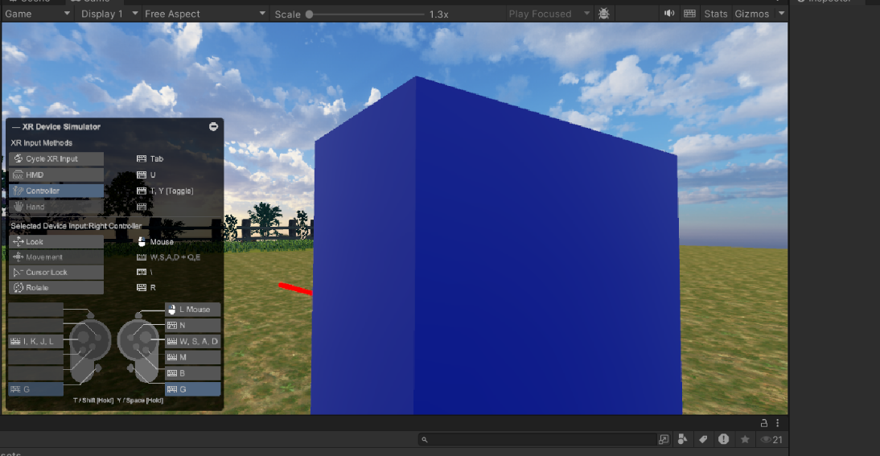

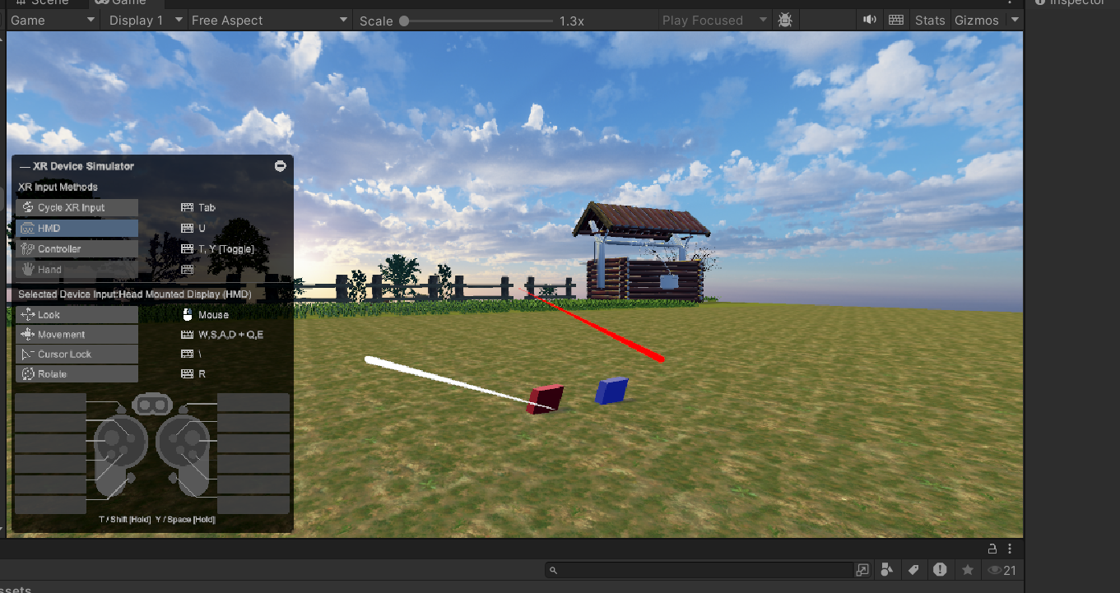

**Task 10: Demo Application**

* Ensure your project runs smoothly by optimizing lighting, reducing unnecessary objects, and lowering the texture size.
* Go to File > Build Settings.
* Select the platform and set the project to VR Supported.
* Run the Application